**Exercise: Explaining the increase**

**Introduction**

One of the essential tasks of the marketing department in any business is to monitor the company's performance, assess trends, and highlight any unusual results or anomalies. In a retail environment, they would keep track of the sales performance over time and identify any unusual rise or fall in results. This vital information allows the business to quickly rectify errors or capitalize on positive results.

In this exercise you will explore how you can use Microsoft Power BI features to quickly identify this type of crucial data. You will be asked to identify the two big sales spikes in the dataset and analyze them. You will apply the clustering technique to separate the data points into similar categories and then use the explain the increase tool of the **Analyze** feature to generate and add visualizations in your report and identify the driving factors behind this increase.

**Case study**

The marketing department at Adventure Works has identified an unexpected surge in bike sales on two distinct days in the previous month. Once they notified the senior management team of this sharp increase, the information caught the eye of the CEO. They have informed the marketing department that they are keen to identify the contributing factors behind this growth so that the company can capitalize on it and propel the business forward.

The manager of the marketing department has asked the analytics department to determine the reason for the surge in bike sales. It is important that the contributing factors are identified quickly as they may be time-specific and if so, the company would need to move quickly to take advantage of them and generate more business. After a brief discussion with your manager Jamie, you both feel that Microsoft Power BI’s **Analyze** feature would be the most effective tool to rapidly generate visualizations that could uncover the driving forces behind the sales surge.

**Instructions**

**Step 1: Download the data**

* Download the Power BI report file titled *Adventure Works Sales Report.pbix* and open it in Power BI Desktop.

[Adventure Works Sales Report](https://d3c33hcgiwev3.cloudfront.net/7UL_uALcRBCCkQ8C1bVq2A_c53e2bfe225447b7bffc7f6c97cd17a1_Adventure-Works-Sales-Report.pbix?Expires=1712102400&Signature=Cu5j94Upv4a2Ic9VvB-Wcg4Vb8Kr1pRxU7bNUoe3hR3nkWwmGRnyTA6t8BfqEXUaZAVHZDz7k8yRNxK8xejRY3n~Fa1t4JwDP3SPLGKB7jNpXHDeslArW~s0cfKSIzqP1aT-AhpuhMUi54gFXPEvn5kpalhf5Pgbguml~ivRB0w_&Key-Pair-Id=APKAJLTNE6QMUY6HBC5A" \t "_blank)

[PBIX File](https://d3c33hcgiwev3.cloudfront.net/7UL_uALcRBCCkQ8C1bVq2A_c53e2bfe225447b7bffc7f6c97cd17a1_Adventure-Works-Sales-Report.pbix?Expires=1712102400&Signature=Cu5j94Upv4a2Ic9VvB-Wcg4Vb8Kr1pRxU7bNUoe3hR3nkWwmGRnyTA6t8BfqEXUaZAVHZDz7k8yRNxK8xejRY3n~Fa1t4JwDP3SPLGKB7jNpXHDeslArW~s0cfKSIzqP1aT-AhpuhMUi54gFXPEvn5kpalhf5Pgbguml~ivRB0w_&Key-Pair-Id=APKAJLTNE6QMUY6HBC5A" \t "_blank)

**Step 2: Identify the two big sales spikes**

To begin your analysis, you first examine the dataset you will be working with and create a proper visualization to identify the big sales days.

1. In **Data** view in Power BI, select the **Sales** table so you can familiarize yourself with the dataset.
2. Locate the **Order Date** column, **Order Total column**, as well as an attribute column that could support clustering. The **Product Name** column has high cardinality and is suitable for clustering.
3. Switch back to **Report** view and create a chart to depict a time series analysis, with the **Date** column in the **X-axis** and the **Amount** column in the **Y-axis**. Switch to the **Report** view and create a **Line chart** with **Order Date** on the **X-axis** and **Order Total** on the **Y-axis.** Opens in a new tab
4. With the help of the line chart, identify the two separate days where there was a spike in sales.

**Step 3: Use the clustering technique to assist the Analyze feature**

Before using the **Analyze** feature, it would be helpful to create a new product group using clustering techniques on the dataset.

1. Add a scatter chart with **Product Name** in the **Values** field, **Order Total** on the **X-axis**, and **Product Price** on the **Y-axis**.
2. Select three dots in the top right corner of this scatter chart and select **Automatically find clusters**.
3. Assign names and descriptions to your clusters and then enter **3** as the number of clusters.

**Step 4: Use the Analyze feature to generate automated visualizations**

After creating the clusters, it is time to use the Analyze feature on the days showing a sales surge to identify trends and patterns.

1. Identify the day with the most sales and use the **Explain the increase** tool of the analyze feature. Make a note of the percentile increase in the **Sum of Order Total**.
2. Note the five specific categories that seem to have had the most influence on the sales spike for that day.
3. Now pinpoint the day with the second highest number of sales and use the **Explain the increase** tool of the analyze feature on that day as well.
4. Using the analyze feature, identify which positive elements appear on this day as well. There are three shared contributory factors between the two days.

**Step 5: Act on the insights by using the Analyze feature**

The three fields mainly contributing to the sales increase have now been identified. You can now create visualizations and add them to the report.

1. Adjust the size of the two visualizations on the screen to an appropriate size for viewing.
2. It’s now time to add more insightful visualizations to the report. Switch back to **Data** view to identify the fields that will be added to visualizations.
3. Determine the number of distinct values in each field to aid you in the creation of the visualizations.
4. There is a field with two distinct values, a field with three distinct values, and a field with seven distinct values. Return to **Report** view and create two visualizations that properly depict a two or three value column and add them to your report.

**Step 6: Act on the insights by Analyze feature**

There is still one category to add to the report. You decide to use the **Analyze** feature again to review the impact of the result and add the last visualization to your report.

1. On the line chart, navigate back to the pop-up window produced by the **Explain the increase** choice in the **Analyze** feature for the 7th of March.
2. Scrolling through the generated visualizations, determine if any of them lack insights, and provide feedback to Power BI that it wasn’t helpful. This will improve the functioning of the **Analyze** feature in your future reports.
3. Locate the three most important factors for the increase and provide positive feedback to Power BI.
4. In the specific category that hasn’t been visualized yet in the report, add the automatically generated visual to the report.
5. Now that all five visualizations are in the report, resize and customize them as per your preference before saving the report.

**Conclusion**

In this exercise, you used the **Analyze** feature to swiftly produce insightful results on your report. Walking through a practical example and following exactly the thought process of a data analyst, you were able to identify that the surge in bike sales was due to a high-selling performance of **Road Bikes** with a **Medium** product size. Working on this task you gained the experience of working with data and the power of the **Analyze** feature and the speed with which it generates results.

**Exemplar: Explaining the increase**

**Introduction**

In the exercise *Explaining the increase*, you were asked to use the **Analyze** feature in Microsoft Power BI to explain unexpected increases in sales totals and provide insights on the reasons for these increases.

More specifically, you were asked to:

* Use clustering in a **Scatter** chart to add product clusters that would assist the **Analyze** feature.
* Create a **Line** chart from the sales figures to identify the dates where a sales surge occurred, and then use the **Analyze** feature to detect the reason for these increases.
* Add to the report all the relevant visualizations based on the insights generated by the **Explain the increase** tool in Power BI.

This reading will provide you with a detailed guide that you can use to compare your solution.

**Explaining the increase**

**Step 1: Download the data**

* Download the Power BI report file *Adventure Works Sales Report.pbix* andload it into Power BI Desktop.

**Step 2: Identify the two big sales spikes**

1. In **Data view** in Power BI, select the **Sales** table so you can familiarize yourself with the dataset.

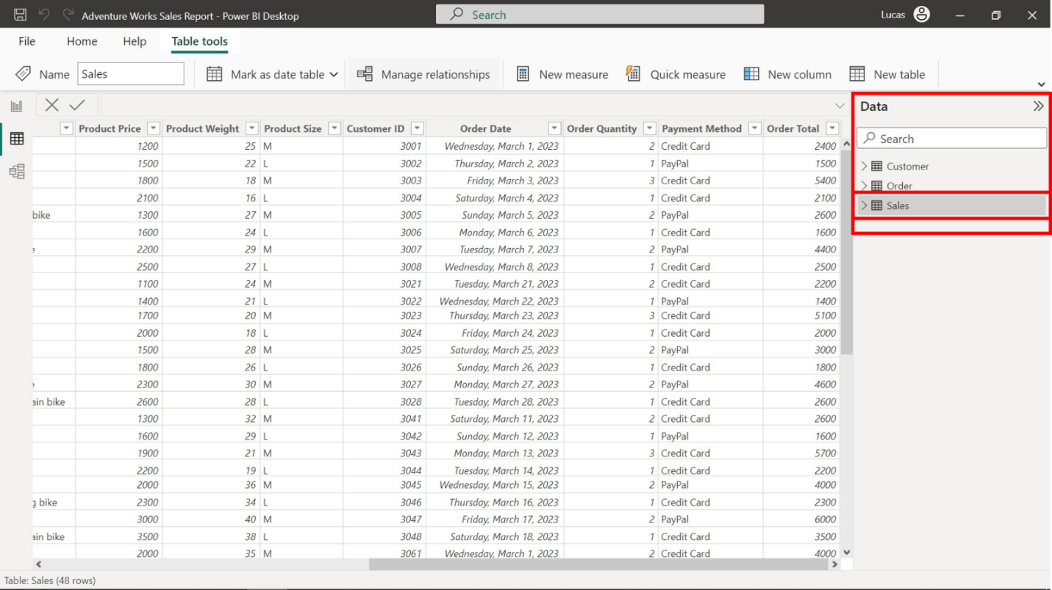

1. Locate the **Order Date** column, **Order Total** column, as well as an attribute column that could support clustering. In this case, the **Product Name** column has high cardinality (high number of distinct values) and is suitable for clustering.

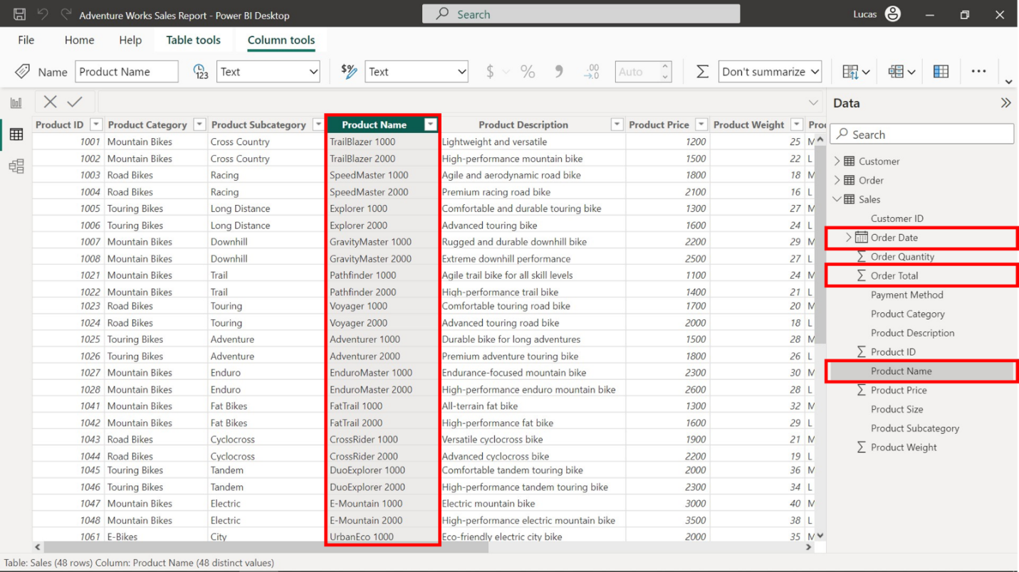

1. Switch to the **Report view** and create a **Line chart** with **Order Date** on the **X-axis** and **Order Total** on the **Y-axis**.

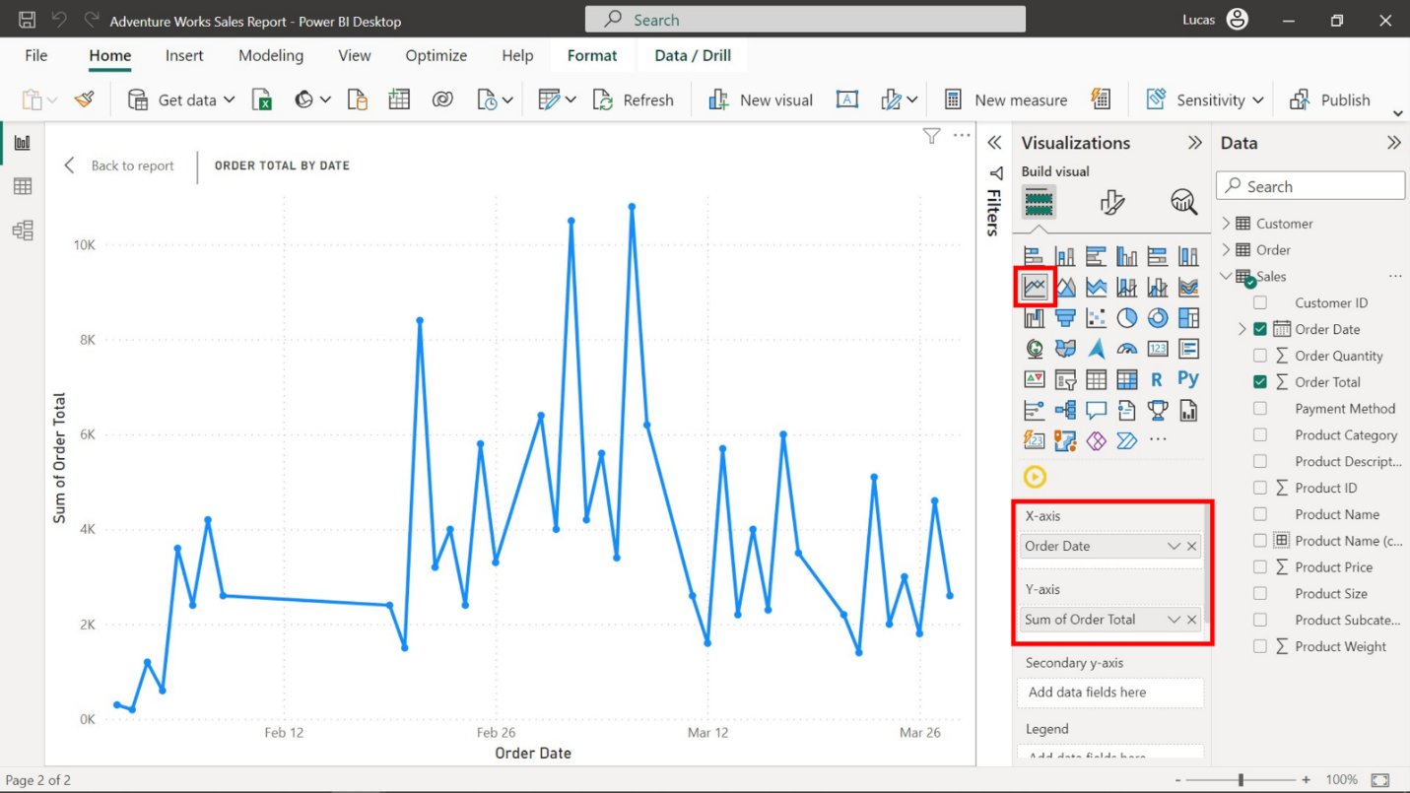

1. With the help of the line chart, identify the third and seventh of March as the two separate days where there was a spike in sales.

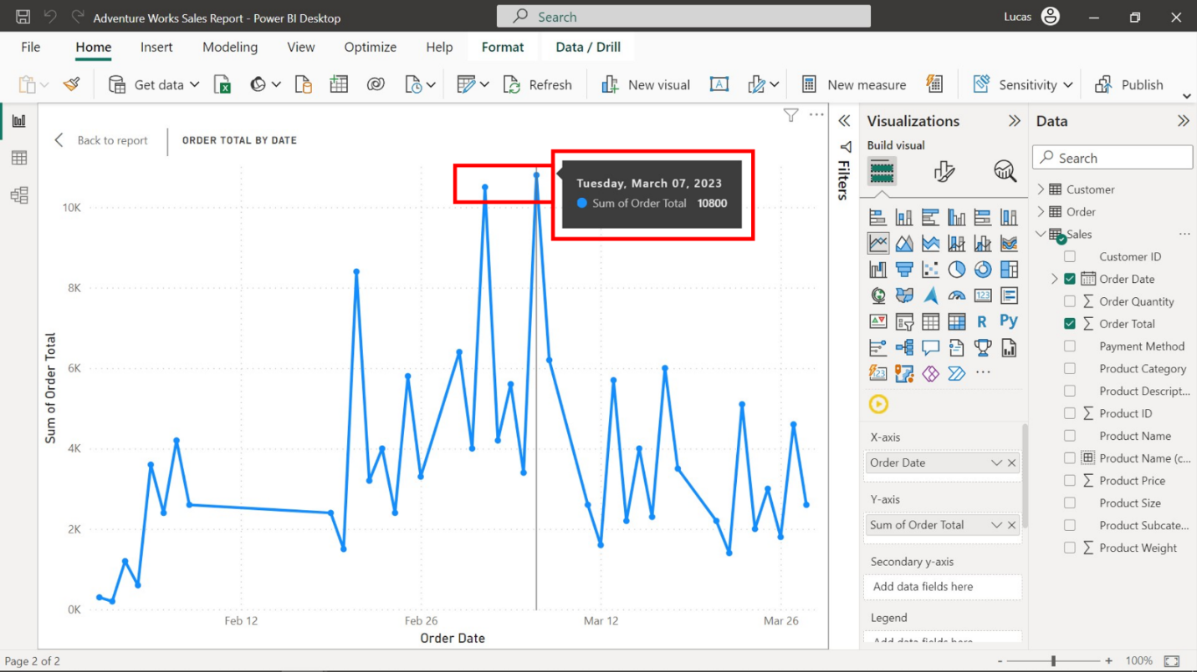

**Step 3: Use the clustering technique to assist the Analyze feature**

1. Add a scatter chart with **Product Name** in the **Values** field, **Order Total** on the **X-axis**, and **Product Price** on the **Y-axis**. Because outliers exist in the dataset, a clustering technique will further help you in your analysis.
2. Select the ellipsis in the top right, and then select **Automatically find clusters**.

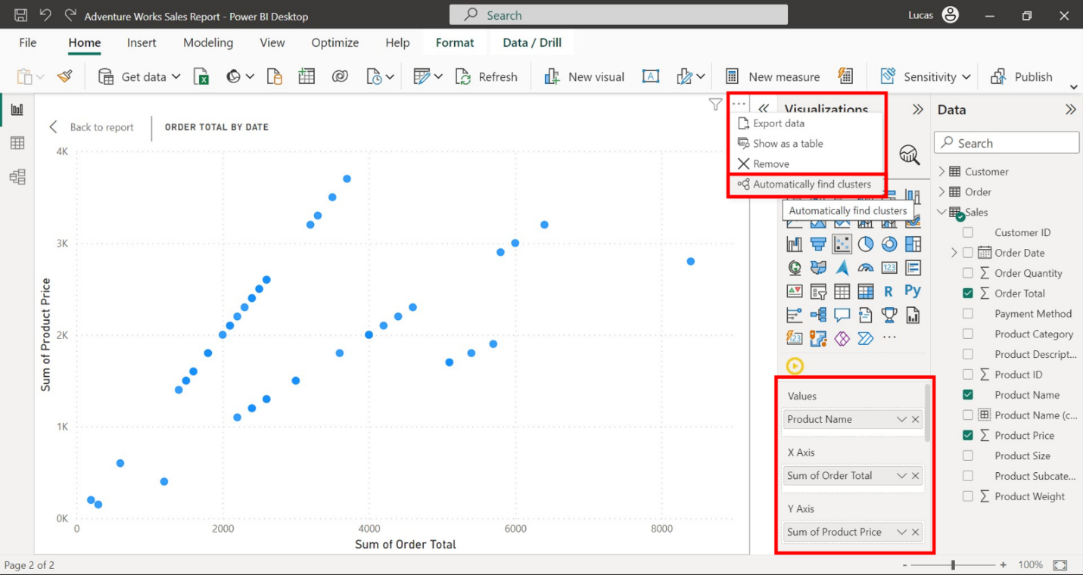

1. Assign names and descriptions to your clusters and then enter three as the number of clusters.

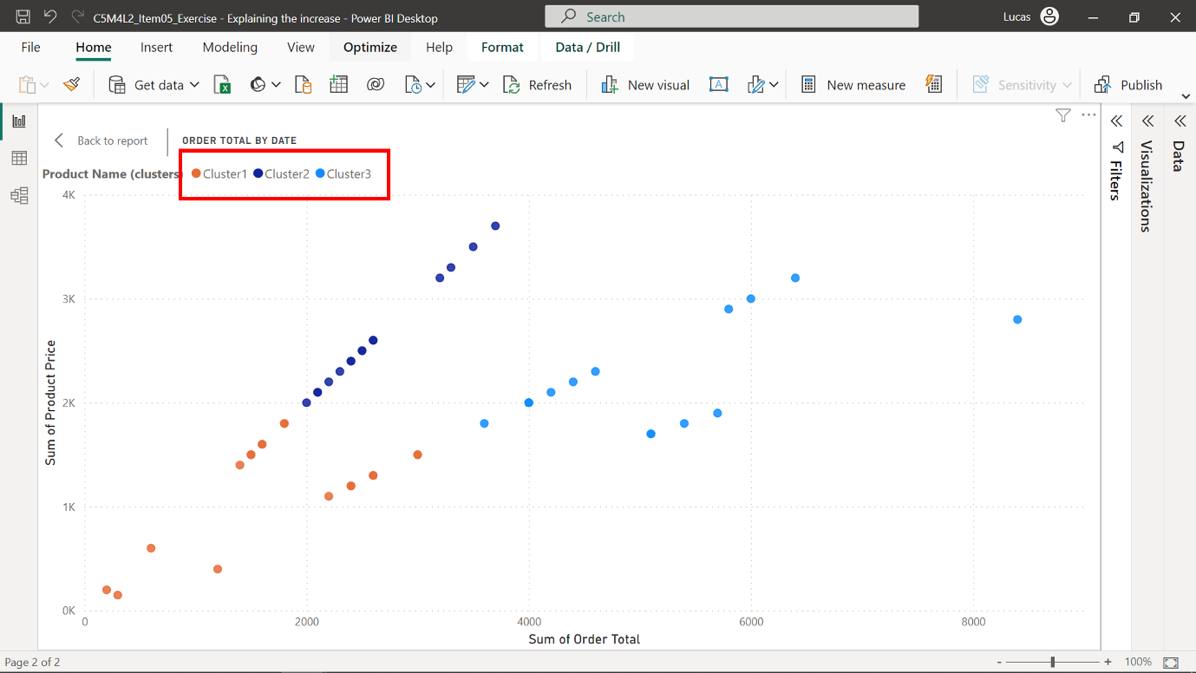

**Step 4: Use the Analyze feature to generate automated visualizations**

1. On the line chart, identify and right-click on the 7th of March. Then select **Analyze** from the list. Select **Explain the increase** to generate visualizations for the selected day.

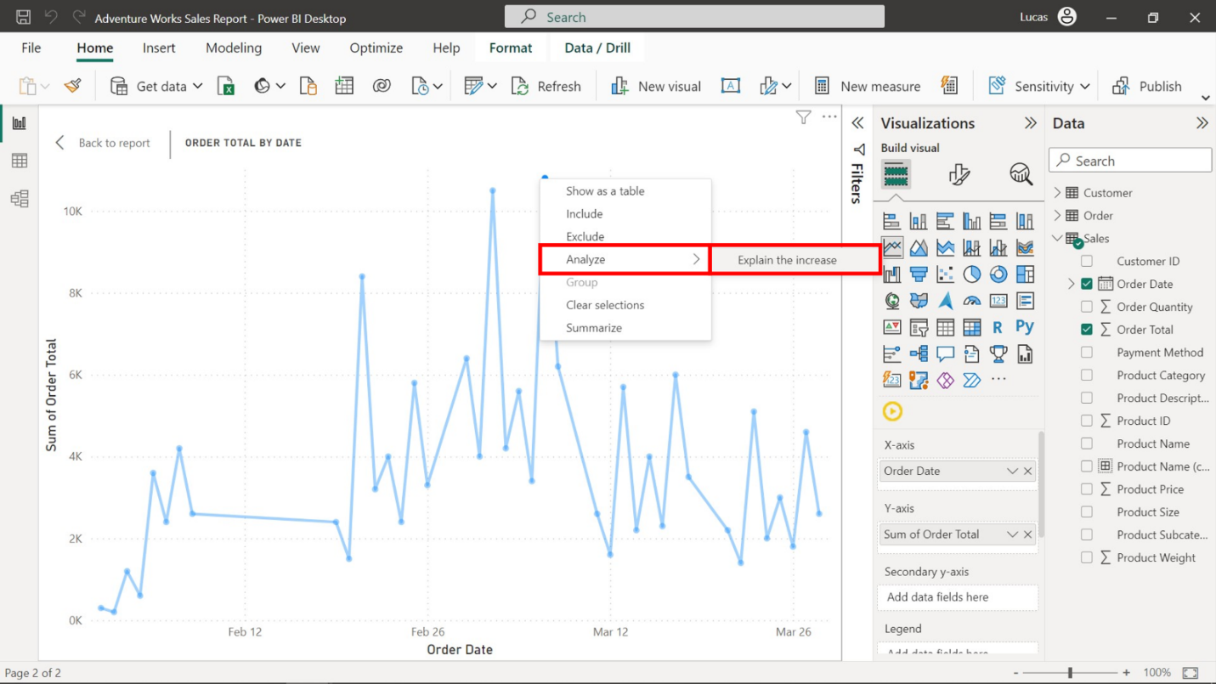

1. Identify the specific fields that had the most influence on the sales spike for that day. **Product Size**, **Product Category**, **Product Cluster**, **Payment Method**, and **Location** had the highest sales spike for that day.
2. Close the pop-up window and right-click on the 3rd of March to use the **Analyze** feature and bring up the explain the increase window for that day as well.

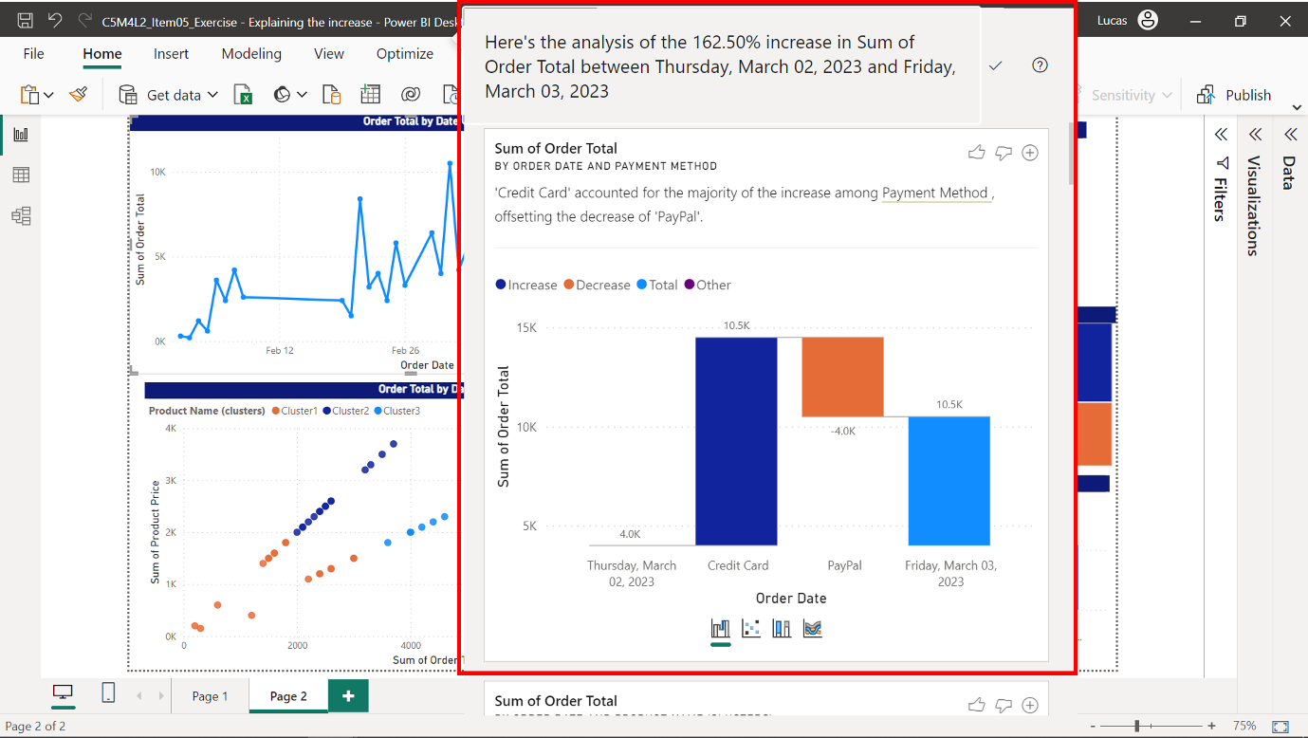

1. Scroll through the window’s visualization to identify the positive elements that also appear on this day. **Product Size**, **Product Category**, and **Product Cluster** seem to contribute to the spike in sales on this day.

**Step 5: Act on the insights by using the Analyze feature**

After identifying the three attributes that contributed to the sales spikes, you were then tasked with adding some insightful visualizations to the report by completing the following steps:

1. Navigate back to the **Data view** todetermine the cardinality (number of distinct values) of the three categories.
2. Note that **Product Size** has a cardinality of 2, **Product Cluster** has a cardinality of 3, and **Product Category** has a cardinality of 7. Then, add the first two categories as visualizations.
3. Since there were only two values, a pie or donut chart could be a good choice. Add a pie or donut visual to depict the difference in **Order Total** accumulated by each of the two product sizes.

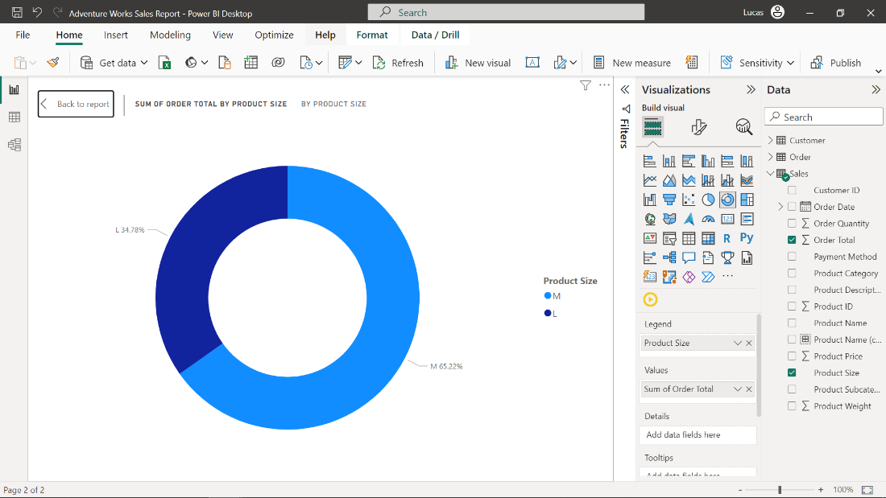

1. Create a treemap to showcase the difference in **Order Total** accumulated by all three of the clusters.

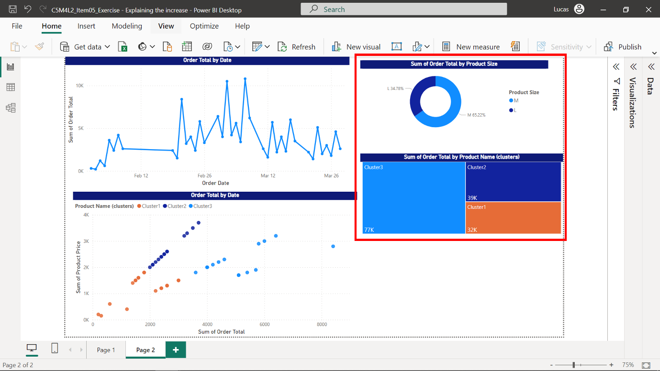

**Step 6: Act on the insights by using the Analyze feature**

1. Upon selecting the line chart, navigate back to the pop-up window by selecting the **Explain the increase** option in the **Analyze** feature for the 7th of March.
2. When reviewing the visualizations that have been created, the single chart that analyzes the **Order Total** by customer surname seems lacking in insights. You can provide helpful feedback to the **Analyze** feature by selecting the thumbs-down button on the top-right.

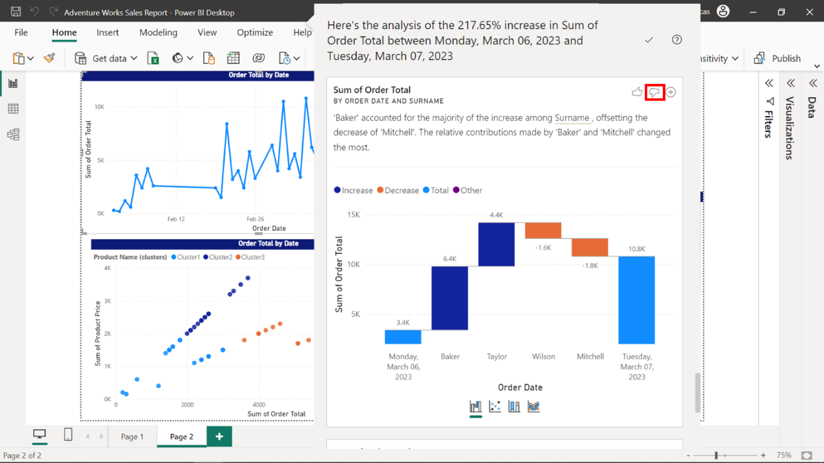

1. Locate the three most important factors for the increase and provide positive feedback on them. These would be **Product Category**, **Product Size**, and **Product Name** (clusters)
2. In the **Product Category** visualization, select the cross button on the top-right to add it to the report.

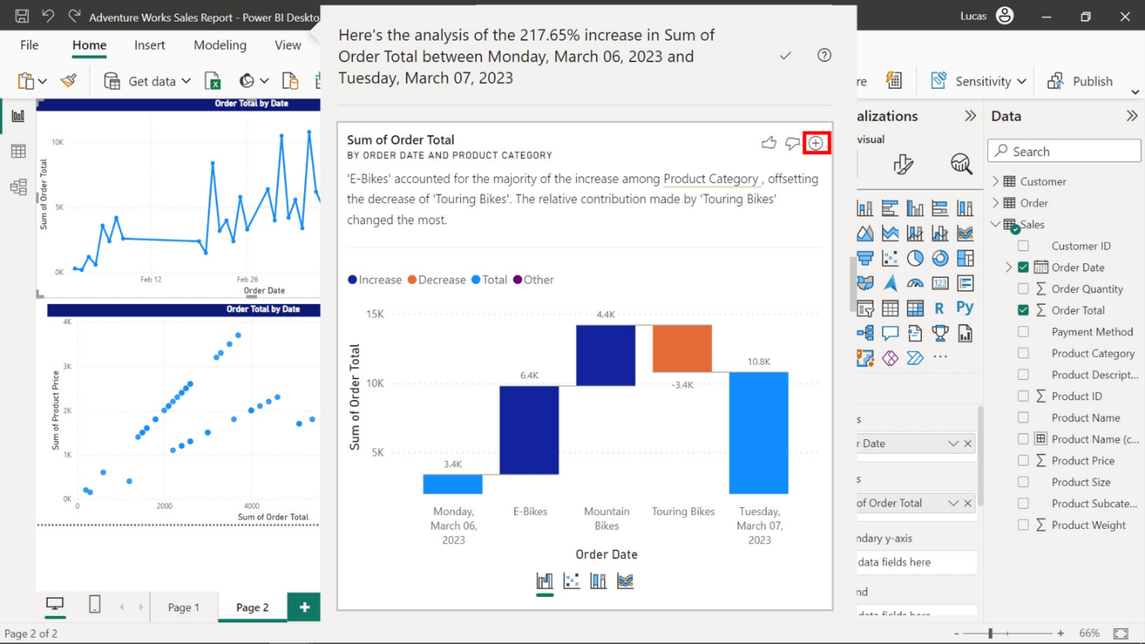

1. Readjust the size of all visualizations to fit the canvas and customize them according to your company’s standards. The outcome of this exercise should be a report similar to the following screenshot.

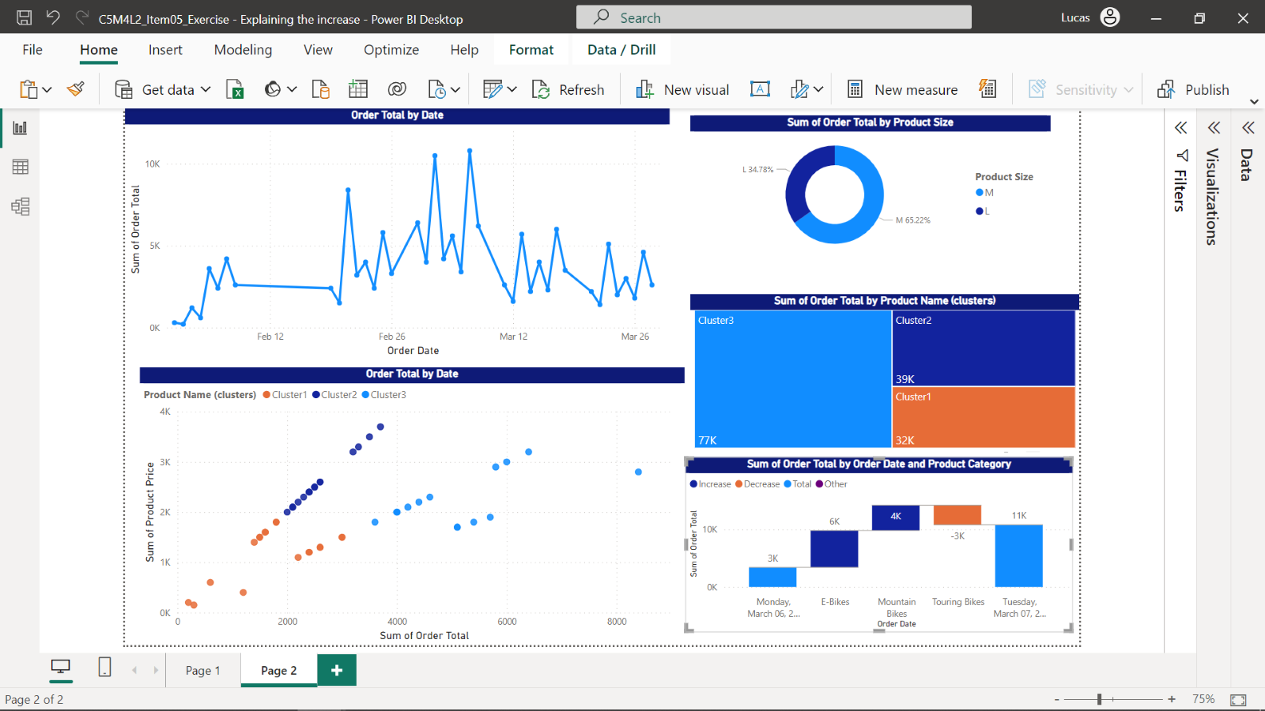

**Conclusion**

In the exercise, *Explaining the increase*, you created an insightful report exploring the sudden increase in Adventure Work’s sales figures by utilizing the tools offered by the **Analyze** feature in Power BI. Your visualizations may vary in formatting and layout from the examples given here because every report bears a unique imprint from the data analyst who crafted it. What is important is that you have provided valuable information and analysis to the Adventure Works management team, which can inform decisions related to the next steps they need to take to maintain the increase in sales.